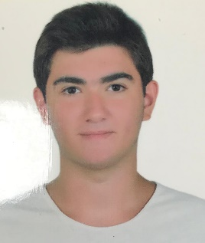**Kutay Mehmet Özkoç**

Çukurambar Mah. Budapeşte Cad. 7/37 Çankaya, Ankara 06800

Mobile: +90 542 718 71 61

E-mail [kutayozkoc99@gmail.com](mailto:kutayozkoc99@gmail.com)

**Personal Information**

**Name, Surname:** Kutay Mehmet Özkoç

**Gender:** Male

**Citizenship:** Republic of Turkey

**Date of Birth & Place:** 06.08.1999 / Ankara, Turkey

**Driving License:** B Level

**Education**

**2017-2021 Başkent University, Ankara**

**Computer Engineering**

**GPU : 2.29**

**2013-2017 Gazi Koleji Fen Lisesi**

**GDP: 91.67 out of 100**

**Languages**

Advance English

Beginner German

**Computer Skills**

Windows

Linux Ubuntu

MacOs Catalina

Modern Javascript ES7

Advanced C,C++, Perl and Python and Java programming languages

I also used Object Oriented Programming in Java

I prefer java because Java can do a lot of things for different platforms and this language helps me for develop some programs but also I am working on different concepts and different languages

Also in this semester, I am taking Bil480 (Artificial Intelligence) and Bil443 (Software Security) and I am working on NLP and Deep Learning too

**Work Experiences**

Limak Teknoloji Yazılım Savunma Sanayi ve Ticaret A.Ş. Database Internship work in Edrims Project 2020 Summer Internship

**Projects**

A member of ‘Ahbap’: A cooperation association founded by Haluk Levent.

A member of ‘Başkent Computer Society: Official computer engineering club of Başkent University

A member of ‘Developer Student Club Bilkent’ : Official developer society of Google

A member of ‘Google Developer Group’: Offical developer society of Google

A small project that I work by myself which is about ‘Electronic Circuts’.

A member of ‘IEEE’ : Official electric and electronic engineering society.

**Certificates**

2020 Python ile Makine Öğrenmesi Udemy/Şadi Evren Şeker

2020 Sıfırdan İleri Seviye Modern Javascript Dersleri ES7+ Udemy/SadıkTuran

2020 15.Genç Akademi Semineri

2019 ML Weekend

2018 Metu Advanced English Course

2018 DeepCon’18

2014 Goethe-Zertifikiat A1